You can find this on my github: <https://github.com/princesscorn/assignments-antra.git>

# FAQ

## 1 What does SQL Profiler do?

Microsoft SQL Server Profiler is a graphical user interface to SQL Trace for monitoring an instance of the Database Engine or Analysis Services. You can capture and save data about each event to a file or table to analyze later.

## 2 What's the life scope of local variable in SQL Server?

The scope of a local variable is a batch, it lasts from the point it is declared until the end of the batch or Transact-SQL or stored procedure in which it is declared.

## 3 What are the databases in system databases folder and what's their functionalities?

There is total 5 System Databases, out of these you can see 4 under the System Databases folder. The 5th database is Resource which does not appear on SSMS.

| **SYSTEM DATABASES** | |
| --- | --- |
| **System database** | **Description** |
| [master](https://docs.microsoft.com/en-us/sql/relational-databases/databases/master-database?view=sql-server-ver15) | Records all the system-level information for an instance of SQL Server. |
| [model](https://docs.microsoft.com/en-us/sql/relational-databases/databases/model-database?view=sql-server-ver15) | Is used as the template for all databases created on the instance of SQL Server. Modifications made to the **model** database, such as database size, collation, recovery model, and other database options, are applied to any databases created afterward. |
| [msdb](https://docs.microsoft.com/en-us/sql/relational-databases/databases/msdb-database?view=sql-server-ver15) | Is used by SQL Server Agent for scheduling alerts and jobs. |
| [tempdb](https://docs.microsoft.com/en-us/sql/relational-databases/databases/tempdb-database?view=sql-server-ver15) | Is a workspace for holding temporary objects or intermediate result sets. |
| [Resource](https://docs.microsoft.com/en-us/sql/relational-databases/databases/resource-database?view=sql-server-ver15) | Is a read-only database that contains system objects that are included with SQL Server. System objects are physically persisted in the **Resource** database, but they logically appear in the **sys** schema of every database. |

## 4 Which statements are DDL statements, which are DML statements?

DDL is short name of Data Definition Language, which deals with database schemas and descriptions, of how the data should reside in the database. It’s common statements:

CREATE, ALTER, DROP, TRUNCATE, COMMENT, RENAME

DML is short name of Data Manipulation Language which deals with data manipulation and includes most common SQL statements such SELECT, INSERT, UPDATE, DELETE, etc., and it is used to store, modify, retrieve, delete and update data in a database.

# Assignment

## 1. Write a query that retrieves the columns ProductID, Name, Color and ListPrice from the Production.Product table, with no filter.

**Solution:**

SELECT ProductID, Name, Color, ListPrice FROM Production.Product;

## 2 Write a query that retrieves the columns ProductID, Name, Color and ListPrice from the Production.Product table, excludes the rows that ListPrice is 0.

**Solution:**

SELECT ProductID, Name, Color, ListPrice FROM Production.Product WHERE ListPrice <> 0;

## 3 Write a query that retrieves the columns ProductID, Name, Color and ListPrice from the Production.Product table, the rows that are NULL for the Color column.

**Solution**:

SELECT ProductID, Name, Color, ListPrice FROM Production.Product WHERE Color IS NULL;

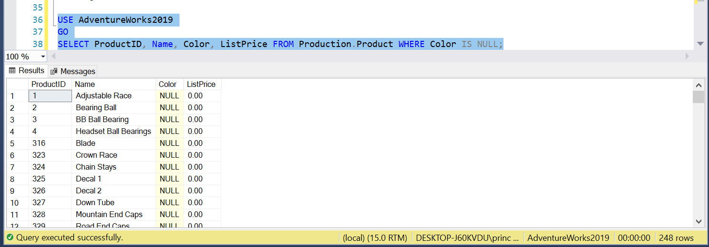

## 4 Write a query that retrieves the columns ProductID, Name, Color and ListPrice from the Production.Product table, the rows that are not NULL for the Color column.

**Solution**:

SELECT ProductID, Name, Color, ListPrice FROM Production.Product WHERE Color IS NOT NULL;

## 5 Write a query that retrieves the columns ProductID, Name, Color and ListPrice from the Production.Product table, the rows that are not NULL for the column Color, and the column ListPrice has a value greater than zero.

**Solution**:

SELECT ProductID, Name, Color, ListPrice FROM Production.Product

WHERE Color IS NOT NULL AND ListPrice > 0;

## 6 Write a query that concatenates the columns Name and Color from the Production.Product table by excluding the rows that are null for color.

**Solution**:

SELECT [Name] + ' : ' + Color AS [Name and Color] FROM Production.Product

WHERE Color IS NOT NULL;

## 7 Write a query that generates the following result set from Production.Product:

NAME: LL Crankarm -- COLOR: Black

NAME: ML Crankarm -- COLOR: Black

NAME: HL Crankarm -- COLOR: Black

NAME: Chainring Bolts -- COLOR: Silver

NAME: Chainring Nut -- COLOR: Silver

NAME: Chainring -- COLOR: Black

**Solution**:

SELECT 'NAME: ' + [Name] + ' -- ' + 'COLOR: ' + Color AS [Name and Color]

FROM Production.Product WHERE COLOR IS NOT NULL;

## 8 Write a query to retrieve the to the columns ProductID and Name from the Production.Product table filtered by ProductID from 400 to 500

**Solution**:

SELECT ProductID, Name FROM Production.Product WHERE ProductID BETWEEN 400 AND 500;

## 9 Write a query to retrieve the to the columns ProductID, Name and color from the Production.Product table restricted to the colors black and blue

**Solution:**

SELECT ProductID, Name, Color FROM Production.Product WHERE Color IN ('black', 'blue');

## 10 Write a query to get a result set on products that begins with the letter S.

**Solution:**

SELECT ProductID, Name, Color, ListPrice FROM [Production].[Product] WHERE Name LIKE 'S%'

## 11 Write a query that retrieves the columns Name and ListPrice from the Production.Product table. Your result set should look something like the following. Order the result set by the Name column.

Name ListPrice

Seat Lug 0,00

Seat Post 0,00

Seat Stays 0,00

Seat Tube 0,00

Short-Sleeve Classic Jersey, L 53,99

Short-Sleeve Classic Jersey, M 53,99

**Solution:**

SELECT Name, ListPrice FROM Production.Product WHERE Name LIKE 'S%' Order by Name;

## 12 Write a query that retrieves the columns Name and ListPrice from the Production.Product table. Your result set should look something like the following. Order the result set by the Name column. The products name should start with either 'A' or 'S'

Name ListPrice

Adjustable Race 0,00

All-Purpose Bike Stand 159,00

AWC Logo Cap 8,99

Seat Lug 0,00

Seat Post 0,00

**Solution1:**

SELECT Name, ListPrice FROM Production.Product WHERE Name LIKE '[AS]%' ORDER BY Name;

**Solution2:**

SELECT Name, ListPrice FROM Production.Product WHERE Name LIKE 'A%' OR Name LIKE 'S%' ORDER BY Name;

## 13 Write a query so you retrieve rows that have a Name that begins with the letters SPO, but is then not followed by the letter K. After this, zero or more letters can exist. Order the result set by the Name column.

**Solution:**

SELECT Name, ListPrice FROM Production.Product WHERE Name LIKE 'SPO[^K]%' ORDER BY Name;

## 14 Write a query that retrieves unique colors from the table Production.Product. Order the results in descending manner.

**Solution:**

SELECT DISTINCT Color FROM Production.Product ORDER BY Color DESC;

## 15 Write a query that retrieves the unique combination of columns ProductSubcategoryID and Color from the Production.Product table. Format and sort so the result set accordingly to the following. We do not want any rows that are NULL.in any of the two columns in the result.

**Solution:**

SELECT DISTINCT ProductSubcategoryID ,Color FROM Production.Product

WHERE Color IS NOT NULL AND ProductSubcategoryID IS NOT NULL

ORDER BY ProductSubcategoryID,Color

